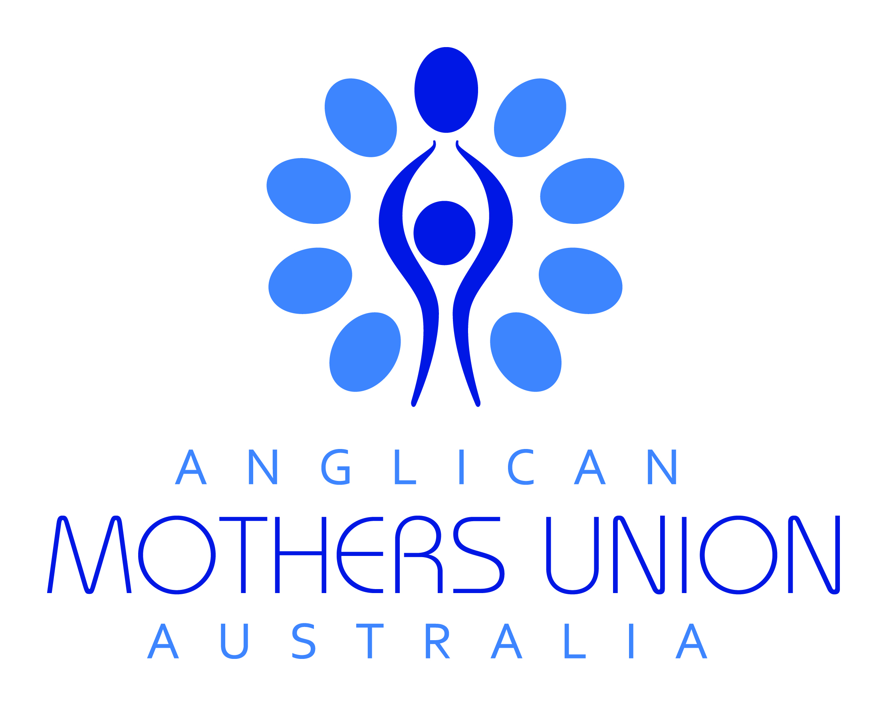 Thought for the Week from Mothers union australia
- Sunday 5 april 2020

Holy week

Holy Week is a roller-coaster ride from joy to sorrow. When you are on a roller-coaster, perhaps at a fair or hurtling along in real life, you hang on for dear life and Trust in the process. You may be preparing for a wedding, a funeral orwatching a teen teetering on the brink of success or failure. The Church from the first centuries relived this week: let reading each of the gospel accounts be some of your Holy Week building hope and confidence work.

Rejoice greatly, O daughter Zion! Shout aloud, O daughter Jerusalem! Lo, your king comes to you; triumphant and victorious is he, humble and riding on a donkey, on a colt, the foal of a donkey. Zechariah 9:9

The Parenting Programme in the Americas has been successful in helping parents manage the roller-coaster of family relationships. Now the programme is planned for the Cree nation in Canada. May God bless all who go forward in faith, hope and love.
Thought for the Week from Mothers union australia
- Sunday 12 april 2020

Christ is risen!

‘Youth is wasted on the Young’. Surely that sentiment is merely an expression of regret. Can we then say that older age is wasted on the elderly? When as Christians we are given NEW BIRTH, it is not to rue our spent youth or the limitations of older age but to be FULLY ALIVE in Christ.
Trust is not dependent on muscle power but on truly believing a living hope. New birth gives new sight, new understanding, new love. John Keble’s hymn, New every morning expresses some of the art of living in the light of Christ. Verse 3 suggests that Christian living is about realigning our hearts and minds to seeing the holy – and no regrets.

If on our daily course, our mind
Be set to hallow all we find
New treasures still of countless price
God will provide for sacrifice.
Hymns A&M Revised No 4; Hymns A&M New Standard No 2; New English Hymnal No 2.

Blessed be the God and Father of our Lord Jesus Christ! By his great mercy he has given us a new birth into a living hope through the resurrection of Jesus Christ from the dead. 1 Peter 1:3

Mothers’ Union worldwide campaigns against traditional practices such as child marriage and female genital mutilation. For all involved in changing minds there is hope and love but danger as well. In Kenya some girls need to move to safer areas. We ask God’s blessing on all family members in this time of social upheaval and pray for new life for all.
Thought for the Week from Mothers union australia
- Sunday 19 april 2020

courage

Courage is so much more aligned with doubt and fear than you would expect. Let’s face it, it doesn’t require courage to tell people about what you think is right and wrong; that action is governed by the mind. Courage is heart-action; the very name is heart in French Coeur. Remember the Lion in the Wizard of Oz, he lacked courage, he didn’t have a heart. Courage and Love work together to meet people where THEY are. For that is what Jesus did, greeting a woman not of his faith, in the street and discussing theology (men’s business) with her. You have to have courage/heart to do that. Use the Taize chant to ask the Lord to fill you with His love and kindness.

Wait for the Lord, whose day is near. Wait for the Lord: Keep watch, take heart!

I hereby command you: Be strong and courageous; do not be frightened or dismayed, for the Lord your God is with you wherever you go. Joshua 1:9

Members in Sudan, where Christianity is very much in the minority, have to have courage. They are 1% of the population but are growing. They reach out to all regardless of gender, age religion or tribe. God guard them and keep their heart and minds open.
Thought for the Week from Mothers union australia
Sunday 26 april 2020

holiness

Holiness is a quality that is best acknowledged in the other rather than sought for oneself. As we read on Easter Day, the hymn writer, John Keble urged us to start with thinking and seeing holiness, ‘to hallow’ all we find. Remember we and the whole wide world is God’s creation. When we ‘hallow’ the person selling The Big Issue our mind is tuned (imperceptibly) further to the dial of holiness. Holiness grows in us as we act according to God’s holy law of Love. Of course, we move towards a godly life. Richard Foster’s book, A Celebration of Discipline, gives instruction on the 12 classic ways. It is well worth setting out to discover yourself using these disciplines. Mind you, the more you do, the more there is. The Christian search for Holiness is like munching into the Magic Pudding, it doesn’t diminish or run out no matter how much you eat. What delights are in store for those who search after holiness and give as much as they take.

Instead, as he who called you is holy, be holy yourselves in all your conduct; for it is written, “You shall be holy, for I am holy.” 1 Peter 1: 15-16

Members in Madagascar regard their sisters suffering with fistulas as holy in God’s eyes. They embrace those who are outcast and give them skills to regain their self-confidence. Holy bodies and holy minds fed with Holy Scripture begin to trust God again and trust themselves. Thanks be to God, hallowed be His name.
Thought for the Week from Mothers union australia
Sunday 3 may 2020

Urban &rural matters

Let the sowers of seed bless you, great God,
the gardeners and farmers sing your praise.

Let those who work with computers bless you, great God
Those who sweep the offices sing your praise.
Excerpts are taken from Canticle 11, p. 456; Canticle 10, p. 455 in Out of the Silence … Into the Silence by Jim Cotter. Cairns Publications, Harlech, 2006. Used with permission.

Whether we are concerned for herd or bushland or whether we commute to work or mind our grandchildren let us see God’s hand in our human enterprise. Loving God, give us the wisdom to love your creation and make the best habitation for all peoples.

All these blessings shall come upon you and overtake you, if you obey the Lord your God:
Blessed shall you be in the city, and blessed shall you be in the field. Deuteronomy 28:2-3

Modern day slavery is a priority concern of the Canterbury Zone which includes much of Europe. Refugees are the primary victims; their skills are abused in both city and rural areas. We pray God’s blessing on members raising awareness and offering care.

Thought for the Week from Mothers union australia
Sunday 10 MAY 2020

Prayer and praise

A cricketer kisses and raises his helmet heavenward; a tennis player kisses the ground. These gestures of prayer and praise are elemental, they burst forth in many ways because we are made in the image and likeness of God, born to pray and praise. Jesus taught us to address his father in an intimate and trusting way that may not even know words but sense the embrace of Love. Respond with singing, art, gardening, seeing God’s glory in ALL the world. Alleluia!

Rejoice always, pray without ceasing, give thanks in all circumstances; for this is the will of God in Christ Jesus for you. 1 Thessalonians 5: 16-18
Young people often have a natural exuberance which responds to rejoicing in helping others. Two teenagers wanted to join Mother’s Union in UK. Now 20 young members work and pray as their branch assists vulnerable people. We offer our prayers and praise to God for their work.

Thought for the Week from Mothers union australia
Sunday 17 MAY 2020

waiting
When we can text a message to India and talk to a cousin in the Antarctic in real time, having to actually wait for a conversation or an answer to a party invitation seems like agony – and unnecessary. But in real life, time is seasonal, God-made. Waiting is a spiritual exercise which needs to be cherished, pondered over and learnt. If we are disturbed, agitated by waiting, we can set up strategies; the very first is to be thankful for time, waiting time, God’s time. Travelling home from work past houses after house, consider that God made and loves whoever lives behind those walls. Is this the season for my branch (me!) to do something?
I wait for the Lord, my soul waits, and in his word I hope; my soul waits for the Lord more than those who watch for the morning, more than those who watch for the morning. Psalm 130: 5-6

Waiting to grow up and take one’s place in the adult world can be very fraught for some. Members in Wales are God-inspired as they use a strategy of teaching young homeless people new skills like cooking. We thank God for this loving and timely action which is building their self-esteem and confidence to enter the season of living independently.
Thought for the Week from Mothers union Australia
Sunday 24 MAY 2020

The kingdom of god

‘The reign of God was manifest in the deeds of Jesus. As presented in his teaching and work it is essentially God’s Kingdom, not ours. … Jesus had come to do what the Jewish Law could never accomplish – to restore God’s damaged and perverted creation to its original destiny.’ Alan Richardson in A Theological Word Book of the Bible. p. 120-121. God’s kingdom is among us as we read the gospels, and as we ‘be as Christ’ to our neighbour. To God be the power and the glory.

Nor will they say, ‘Look, here it is!’ or ‘There it is!’ For, in fact, the kingdom of God is among you.” Luke 17: 21
Mothers’ Union in All Ireland respond to the perennial problems of gender-based violence, and the many who are alone and dispossessed in modern society. Members bring Christ’s love with personal interaction at community events. May those whom they meet see the Reign of God breaking in.
Thought for the Week from Mothers union australia
Sunday 31 may 2020

Come holy spirit

As with the Kingdom, the Holy Spirit is not our possession, not under our command but is pure Gift. The more we pray to the Father, through the Son and by the Holy Spirit, the less our prayer will be a sort of shopping list or battle plan. It is SO hard to give up control but that is the first thing to go. Remember the last gift of the Holy Spirit is Self-Control. We need to work through all the others and with Self-Control we may find we don’t need to control God’s Kingdom, just BE yourself whom God love absolutely.
But you will receive power when the Holy Spirit has come upon you; and you will be my witnesses in Jerusalem, in all Judea and Samaria, and to the ends of the earth.” Acts 1:8
Knitting is the gifts of members in Scotland to those they know are wounded and lost. Clothes for premature and stillborn babies are tangible expressions of love and understanding and come with and in God’s name. Members also engage Alzheimer’s patient in knitting the tiny clothes. A circle of love and spiritual blessing.
Thought for the Week from Mothers union australia
Sunday 7 JUNE 2020

Celebrating volunteers

Teach us, good Lord, to serve you as you deserve, to give and not to count the cost,
to fight and not to heed the wounds, to toil and not to seek for rest,
to labour and not to ask for any reward, save that of knowing that we do your will. Amen. The Prayer of St Ignatius of Loyola

We celebrate wholeheartedly our volunteer fire fighters this year. They epitomise the noble quality of free will giving. It is a felt pride Australians have in the volunteer op shop worker, school canteen staff and sausage sizzle band. It was an identifiable trait even in 1891: “The voluntary system … is almost universal in Australia”. St Ignatius’ prayer is one expression of Jesus’ call to discipleship, ‘Take up your cross and follow me’. It’s your choice, it’s voluntary, it’s born of love of God and love of others.

A generous person will be enriched, and one who gives water will get water. Proverbs 11:25

In Iraq, where there are no official care or support systems, Mothers’ Union members choose of their own free will and with Christian love, to volunteer their practical outreach work. In Jesus’ name, we thank them.

Thought for the Week from Mothers union australia
Sunday 14 JUNE 2020

Welcoming the stranger

This precept is one of the backbones of Jewish Law. Translated variously as sojourner, alien, stranger: Deut 10:18-19,’ You shall love the stranger’. The books of the Law (Leviticus, Numbers, Deuteronomy) remind the people of Israel again and again and again, Remember, you were once refugees. But in the days of our Lord those who were ‘strange’, in creed, race and lifestyle, were not welcome. Our Lord went to the gallows for befriending them, loving and forgiving them, himself deserted a stranger to his friends. St Peter said, ‘I do not know him’.
Do not neglect to show hospitality to strangers, for by doing that some have entertained angels without knowing it. Hebrews 13:2
After a MULOA workshop in Uganda, members travelled to refugee camps to visit family members from whom they had been separated, in some cases for years. The sojourners were visited in Christ’s name and blessed. The visitors followed Christ’s teaching - when you visited them in my name you visited Me. This worldwide tragedy is distant for many of us.
Thought for the Week from Mothers union Australia
Sunday 21 JUNE 2020

Parenting

What a hot potato this topic is! Perhaps it is helpful (?) to remember the first children were rivals and it all ended badly. And the murderer ended up being the father of the Hebrew nation! Not the narrative a young couple wants to hear with their precious darlings in tow. But surely the lesson here is that human beings are flawed and not everything will be rosy wherever we live and however advantaged we may be. But parents can be informed and more importantly learn the Christian art of touch and love and forgiveness and tolerance, for Jesus is the Saviour of all, even parents.
See what love the Father has given us, that we should be called children of God; and that is what we are. The reason the world does not know us is that it did not know him. 1 John 3:1

The Mothers’ Union bears a worldwide burden and joy of parenting. Each and every one of us will need to continually refocus our vocation and ministry towards that end. We are sacrificial in our use of time to the greater end which is the nurture of parents and children. Let our prayer this week be a form of self-examination, looking truthfully at OUR motives, where our priorities lie, what we may be able to learn in order to make wise decisions.
Thought for the Week from Mothers union Australia
Sunday 28 JUNE 2020

Tranquillity

Stress – serenity, mindfulness – mania, tension – tranquillity. At certain times in our lives we become aware, overrun, obsessed with the struggle to achieve a suitable balance in our lives. Jesus’ withdrawal from the crowds eager for his teaching and healing acceptance is an example of going from one state of tension to another state to achieve equanimity. We often lay guilt upon ourselves for even feeling stressed. If we are naturally laid back, unfussed, perhaps we need to stretch ourselves. Jesus both urges his friends to get up and go and bestows Peace in the upper room.

The Lord lift up his countenance upon you, and give you peace. Numbers 6:26

This year’s theme ‘Building Hope and Confidence’ won’t get off the ground without some pushing and stretching of imaginations and mindsets. Transformation means to change/alter an existing structure or condition. The action to achieve transformation is fed by information and concern which is wonderfully distilled by offering mindful prayer and praise and waiting then with serene and tranquil hearts and minds for God’s gifts.

