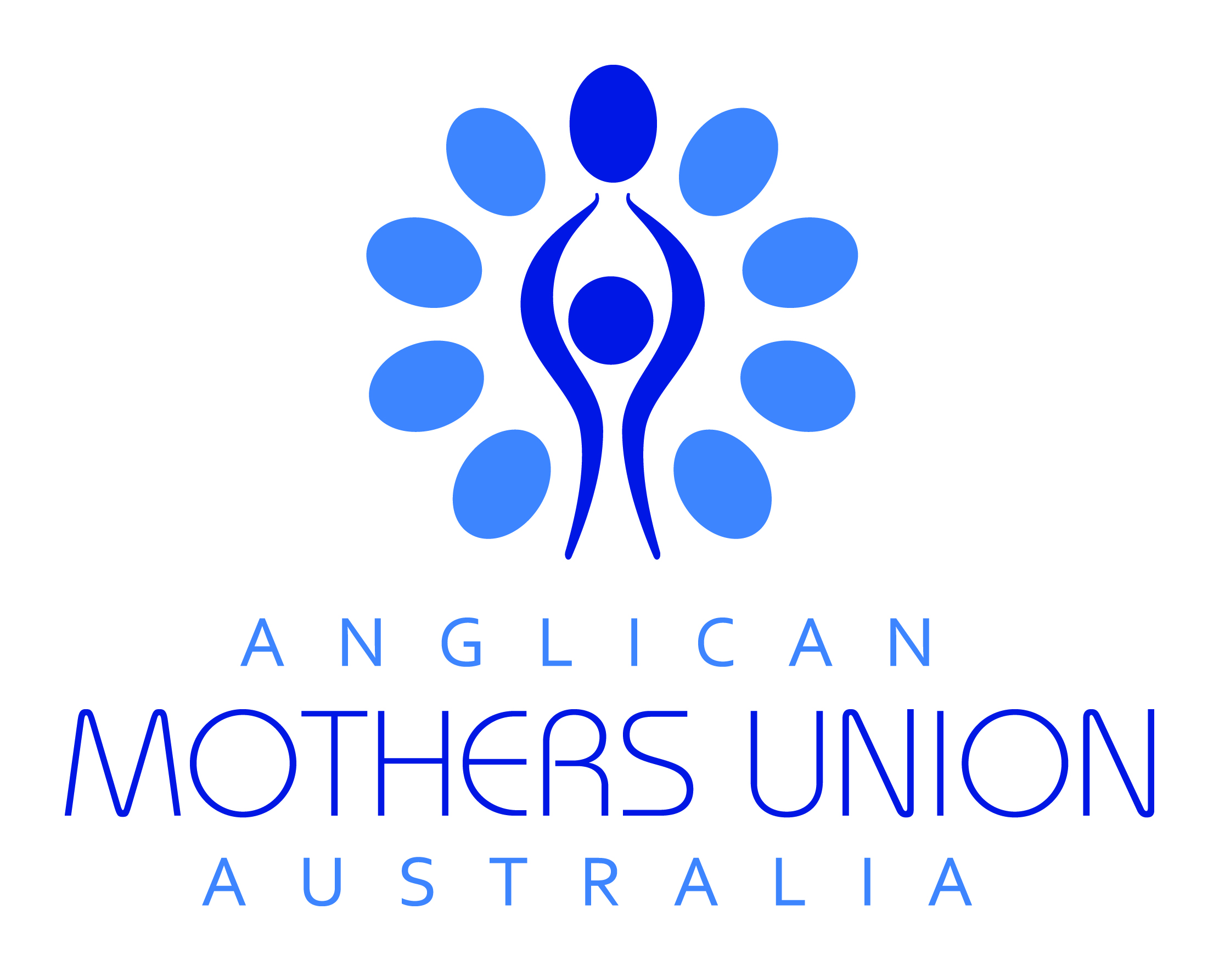
Thought for the Week from Mothers Union Australia
Wednesday 1 January 2020
Faith for the future

God gives us a future, daring us to go. Hymn by Elizabeth Smith. TiS 687

We lose track of the times we plan for the future only to be presented with something completely different. That’s when Faith holds us and carries us through the good and bad times. Faith, Hope and Love come from God and will take us to God no matter what the future holds.

For surely I know the plans I have for you, says the Lord, plans for your welfare and not for harm, to give you a future with hope. Jeremiah 29:11

We hold all Mothers’ Union members throughout the world in prayer. The lives of so many women and children are enriched and trained for the future by our blessed organisation. We hold all families and communities in our hearts as the health and wellbeing and future of children and young people rests in the faith and love with which they are raised.

Thought for the Week from Mothers Union Australia
Sunday 5 January 2020

Discernment

If I were to claim I was ‘discerning’ I would, by inference, be claiming to be wise, have right judgement. However, by claiming that I would NOT be discerning. Discernment we can attribute to others though, such as ‘The Wise Men’ of the gospel. They really proved their credentials: travelling into the unknown, giving their gold and frankincense and myrrh to a mere tot in what amounted to a refugee camp. Let our thoughts and actions be worthy of you, O God

Do not be conformed to this world, but be transformed by the renewing of your minds, so that you may discern what is the will of God—what is good and acceptable and perfect. Romans12:2

Following on from the MULOA process members in Sri Lanka had the skills to discern the need for a new programme, ‘Christ Care’. Families bring disabled children to the parish hall to receive free physiotherapy, special education and food. Thank God for eyes to see and hearts to discern.

Thought for the Week from Mothers Union Australia
Sunday 12 January 2020

Mothers’ Union Mission

Go in peace to love and serve the Lord – the dismissal at the end of the Holy Communion service sends us on our way to be missioners for Jesus, in His name. We are sent as servants as Our Lord Jesus Christ was servant. We are sent as lovers of all people, as He loved all people. Belonging to Mothers’ Union means to not only accept the ‘dismissal’ but also to be alert to the needs of others, to be brave and fearless, and selfless and overflowing with love.

Jesus answered, “You shall love the Lord your God with all your heart, and with all your soul, and with all your strength, and with all your mind; and your neighbour as yourself.” Luke 10:27
The mission for Mothers’ Union in India is human trafficking, in Myanmar it is gender-based violence. Members want to go out and spread the good news God’s love for all, thus raising awareness of accepted practices and promoting the Way of Love.
Thought for the Week from Mothers Union Australia
Sunday 19 January 2020

Christian Unity

We are the body of Christ

‘We are the Body of Christ’, says the president of the eucharist. ‘His Spirit is with us.’ The congregation replies. What wonderfully sensible, biblical words these are. Hearing them on Sunday mornings read from the prayer book reminds us of the unity of Christians. St Paul chose the image of a body to describe the church and when we pray for Christian Unity we need to keep this image in our minds. The brain has very little in common with the skeletal frame in texture, substance, appearance and function. Looked at in that way we who are many are ONE for we all belong to the one BODY which is Christ our Living Lord.

Finally, brothers and sisters, farewell. Put things in order, listen to my appeal, agree with one another, live in peace; and the God of love and peace will be with you. 2 Corinthians 13:11

A common enemy can draw people together: in Northern Argentina Mothers’ Union members joined the Roman Catholic Church on a march in Juraez against their enemy, drugs. Their common cause being to bring Christ’s love to all.

Thought for the Week from Mothers Union Australia
Sunday 26 January 2019

Poverty and homelessness

Why is it that we who live in one of the wealthiest and peaceful nations on earth, can feel such intense NEED. Surely there is irony in the fact that NEED and GREED rhyme. At the root of Poverty and Homelessness is the tragedy of cultural breakdown, war, competing interests for the world’s resources. Our Lord Jesus was born into such a world – on the wrong side of wealth and luxury. Mothers’ Union is commissioned to seek justice for all, out of love for the poor and needy.

How does God’s love abide in anyone who has the world’s goods and sees a brother or sister in need and yet refuses help? Little children, let us love, not in word or speech, but in truth and action.
1 John 3:17-18

Refugees are by definition homeless and in poverty. One MU branch in the USA, was working with African refugees. Rather than give them gifts at Christmas, members asked them what they needed. Now the members host a market-style giveaway event which meets a more urgent need.

Thought for the Week from Mothers Union Australia
Sunday 2 February 2020

Living by faith

Insurance for house, boat, jewels, money in the bank: what does this all mean if we say we are living by faith? If I do (or don’t do) something, will that guarantee happiness or God’s favour, riches, a loving family. Certainly the Hebrew Scriptures (for the most part) tell us God will reward the righteous. But Jesus tells us to consider the lilies, the birds of the air. His life and death show us there are NO guarantees, except that God loves us no matter what. In the face of that love how can we but not go forward in faith and hope and love?
No distrust made him waver concerning the promise of God, but he grew strong in his faith as he gave glory to God, being fully convinced that God was able to do what he had promised.
Romans 4:20-21
In Melanesia the Parenting Programme has contributed to restoring a relationship between an adolescent boy and his family. He returned home after two years of refusing to associate with them. There are no rules that were obeyed but there was a willingness of all involved and LOVE. Let us thank God for the opportunities that members bring to their communities.
Thought for the Week from Mothers Union Australia
Sunday 9 February 2020

Friends and family

We often feel a failure if we don’t get 20 birthday cards or have a group of school friends which has met every week for 60 years. And even more of a failure if our family implodes. Whatever we feel about family and friends we know that Jesus held them in short regard to those who were his TRUE family. Jesus replied, “Who is my mother, and who are my brothers?” And pointing to his disciples, he said, “Here are my mother and my brothers! For whoever does the will of my Father in heaven is my brother and sister and mother.” Matt 12:48a-50. And his friends all deserted him. Let us thank God for friends and family and be true members of Christ.

Some friends play at friendship but a true friend sticks closer than one’s nearest kin.
Proverbs 18:24

An Australian priest said the Mothers’ Union brought him up. When his mother was ill, members tended the children for months. Thus the seeds were laid for his faith. He experienced family and friendship in the church and he subsequently spent his life in service and friendship of God’s church and his people.

Thought for the Week from Mothers Union Australia
Sunday 16 February 2020

Steadfastness

Thou wast their rock, their fortress and their might,
Thou Lord their Captain in the well fought fight,
Thou in the darkest drear their one true light. TiS 455; AHB 384

If Jesus is the model of steadfastness we follow, his followers have also given us examples of steadfastness. In Westminster Abbey there are modern statues of 20th century martyrs such as Boenhoeffer, Martin Luther King, Kolbe. They held themselves like rocks against the tide of prejudice, they fought for the downtrodden, they continue the Christian Way that has been kept alive through 2 millennia. It is the Way of peace and justice for all, a Way that can only be upheld by a continuing steadfast appraisal of the injustices of our times.

Therefore, my beloved, be steadfast, immovable, always excelling in the work of the Lord, because you know that in the Lord your labour is not in vain. 1 Corinthians 15:58

What were accepted practices in Kenya, Rwanda, Uganda and Tanzania – female genital mutilation and child marriage - are now priority areas for advocacy and policy. Members are steadfastly campaigning for a ‘complete stop’ to the practices, sometimes needing to move at-risk girls to safer areas.
Thought for the Week from Mothers Union Australia
Sunday 23 February 2020
Fair Trade

Lent begins this week and we enter the desert with Jesus. St Mark records that the Spirit drove Jesus and we don’t need to imagine his reluctance – we feel it often when faced with a task or responsibility that is uncomfortable, even dreaded. Leaning back, heels dug in, we are pushed to face some home truths. The topic of Fair Trade demands that we look at our responsibility when it comes to how goods are distributed and sold. Lord, give us courage to ask ourselves if the food and clothing we buy has meant hunger and exploitation for others, and destruction of their culture and livelihood.
The righteous know the rights of the poor; the wicked have no such understanding. Proverbs 29:7
We give thanks for members’ work that upholds the values of fair trade, helping people and their communities to take control of their lives with dignity. We ask God’s blessing on their environmental protection work so that farming will flourish despite the challenges of climate change.

Thought for the Week from Mothers Union Australia
Sunday 1 March 2019

Season of Lent

Lent – the highroad or the low road, the familiar fasts or trying something different. Whatever you choose, take the opposite of what you’re used to. Consider, how satisfied are you with your relationship with God? The psalmist quoted below isn’t – dry and thirsty, fainting and weary. Lent is the time for a challenge, for testing your ability to look honestly at yourself.

O God, you are my God, I seek you, my soul thirsts for you; my flesh faints for you, as in a dry and weary land where there is no water. Psalm 63:1

Members in Sudan are very active in their communities despite Christians being 1% of the population. Prayer is essential to all they do such as prison ministry and peace and reconciliation programmes.
Thought for the Week from Mothers Union Australia
Sunday 8 March 2020

Valuing women

‘The Gospel of Our Lord Jesus Christ’, so St Mark begins his account of the life, work and ministry of Jesus Christ, a life which broke through the religious and cultural taboos of his day. Like a tornado the events of chapter 1 go from his baptism, temptation, choosing the twelve, rebuking the unclean spirits and then, after ‘church’, he goes to Simon’s house. There he goes to the bedside of a woman, Simon’s mother-in-law, takes her hand, ‘lifts her up’. He broke the rules, he healed, and showed his followers how to value women. May his gospel lift up all women.

Charm is deceitful, and beauty is vain but a woman who fears the Lord is to be praised.
Proverbs 31:30
Members in central and southern Africa are raising awareness of gender-based violence. Astonishingly, roughly 60 thousand women have been helped. Men are joining a campaign called ‘Not in My Name’ and pledging to protect women.

Thought for the Week from Mothers Union Australia
Sunday 15 March 2020

United nations

A longing for peace and goodwill grasps peoples who are weary of war. Sharing the care of the earth’s natural beauties motivates people shattered by their destruction. Loss makes us more agreeable to compromise and reconciliation. Wealth and power brings disdain for any impediment to the progress of prejudice, fear and disharmony which may be challenged by conciliation between nations.

He shall judge between the nations, and shall arbitrate for many peoples; they shall beat their swords into ploughshares, and their spears into pruning hooks; nation shall not lift up sword against nation, neither shall they learn war anymore. Isaiah 2:4
The integration of refugees in the UK is assisted by members who provide English speaking lessons, thus modelling peace and respect between nations. In the province of York a family of eight were sponsored, supplied with house equipment, school places and uniforms and medical care organised. The United Nations on a local scale. Thanks be to God.

Thought for the Week from Mothers Union Australia
Sunday 22 March 2020

Nurturing

This week begins with Mothering Sunday and then Lady Day follows on Wednesday. The observance of Mothering Sunday is still well observed in the UK. Prayers and liturgies are available on the MU website. Posies and cake touch every heart and there is much to be gained by the recognition of those who nurtured our faith whether mother, father or ‘the lady who showed me the place in the prayer book’. Let us be that nurturing person and help to hand down the care.

He will feed his flock like a shepherd; he will gather the lambs in his arms, and carry them in his bosom, and gently lead the mother sheep. Isaiah 40:11
This week as we also remember Mary Sumner’s vision, let us pray for those children unable to be cared for by their parents and who need the safety and security of foster parents. Love is the healer of all wounds. Let us pray for those children starved of love.

Thought for the Week from Mothers Union Australia
Sunday 29 March 2020

Heart for justice

When our hearts yearn for justice, it is not with the sense of wanting retribution or revenge.
Justice is what God delivers. Being Just is an attribute of God as is Righteousness and Mercy. A heart that aches for justice will yearn and work for others to have wrongs righted, mercy delivered. The yearning for justice is not for oneself. We do want to be right with God, we do want God to have mercy on us, but our prayer is always for the down-trodden other.

Therefore the Lord waits to be gracious to you; therefore he will rise up to show mercy to you.
For the Lord is a God of justice; blessed are all those who wait for him. Isaiah 30:18

Members in Nigeria were among others in Zone E who wanted to focus their support on the vulnerable and marginalised and those in poverty. With a heart for justice they felt advocacy, education and connecting people to government provisions would help to combat the injustices of disadvantage. As we move into Holy Week may our hearts be open and discerning and may God bless us all.

